**Information System Management Lab**

**BCOM 307**

**Assignment #15**

***Submitted by:***

**Name:** YASH JAIN

**Enrollment No:** 03914788818

**Semester:** B.COM(H) 5th Semester

**Class:** B.COM(H)

**Section:** B.Com 5A

**Date of Submission:** 11/10/2021

***Submitted to:***

**Praveen Kumar Singh**

**Assistant Professor, MAIMS**



**Department of Commerce**

**Maharaja Agrasen Institute of Management Studies**

**Affiliated to Guru Gobind Singh Indraprastha University, Delhi**

**Sector -22, Rohini, Delhi -110086, India; www.maims.ac.in**

Maharaja Agrasen Institute of Management Studies

Affiliated to GGS IP University; Recognized u/s 2(f) of UGC Recognized by Bar Council ofIndia; ISO 9001: 2015

Certified Institution Sector 22, Rohini, Delhi -110086, India; [www.maims.ac.in](http://www.maims.ac.in/)

Department of Commerce

Academic Year: 2020-21

Semester: Vth

# Assignment No. 15

# Unit No:

**Course/Subject Code:** BCOM 307 **Subject Title: Information System Management Lab**

# Issue Date Last Date of Submission:

**Instructions for Students:**

# All Questions are Compulsory.

1. The student should attach proper cover page for each assignment clearly mentioning the Assignment No.
2. Each assignment should be prepared by the student individually with proper explaination and screenshots.
3. A4 size ruled sheets should be used for the assignment.
4. Assignment pages should be serially numbered at the bottom of page.

***During online education mode, upload scanned copy of the complete assignment including cover page latest by due date.***

|  |  |  |
| --- | --- | --- |
| **Question No.** | **Question** | **CO No.** |
| 1 | Return the number of non-null values for salary column in the client_master table. | **CO1, CO2, CO3, CO4** |
| 2 | Show the total number of records in client_master table. |
| 3 | Show the distinct state number in client_master table. |
| 4 | Show the total balance due in client_master table. |
| 5 | Show the average salary of client_master |
| 6 | Show the minimum salary of client_master. |
| 7 | Show the maximum balance of client_master. |

**ASSIGNMENT 15 - AGGREGATE FUNCTIONS**

**Task 1 : Return the number of non-null values for salary column in the client_master table.**

This task can be completed using the **COUNT() aggregate function**. An aggregate function is a function where values of multiple rows are grouped together as input on certain criteria to form single value of more significant meaning. Count() returns the number of rows where expression is not null. The syntax is -

Select count([distinct] [<all>] <exp>) from <tablename>;

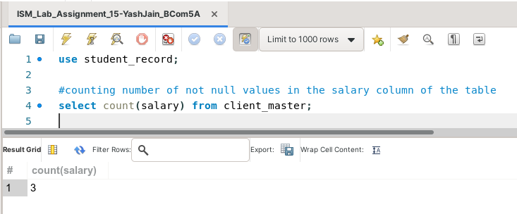

**Task 2: Show the total number of records in client_master table.**

This task can be completed using the **COUNT(*) aggregate function**. It returns the number of rows in the table, including duplicates and rows with null values.

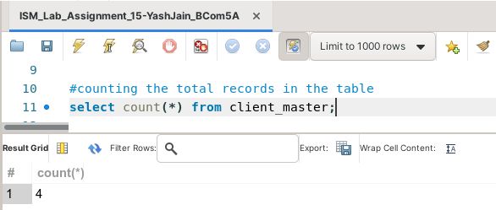

**Task 3: Show the distinct state number in client_master table.**

This task can be completed using the **COUNT() aggregate function**, along with the **Distinct** clause.

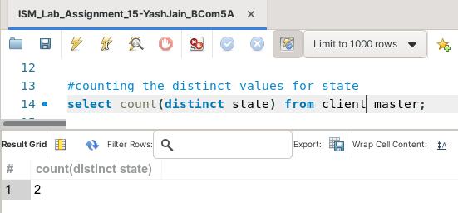

**Task 4: Show the total balance due in client_master table.**

This task can be completed using the **SUM() aggregate function**. The sum() function returns the sum of ‘n’ values of an attribute in a table. The syntax for this is -

Select sum([distinct] [<all>] <n>) from <tablename>;

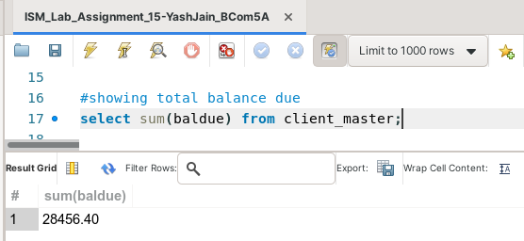**Task 5: Show the average salary of client_master.**

This task can be completed using the **AVG() aggregate function**. The avg() function returns the average of ‘n’ values of an attribute in a table. The syntax for this is -

Select avg([distinct] [<all>] <n>) from <tablename>;

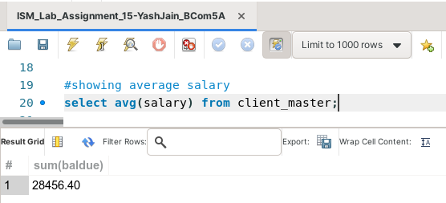

**Task 6: Show the minimum salary of client_master.**

This task can be completed using the **MIN() aggregate function**. The min() function returns the minimum of ‘n’ values of an attribute in a table. The syntax for this is -

Select min([distinct] [<all>] <n>) from <tablename>;

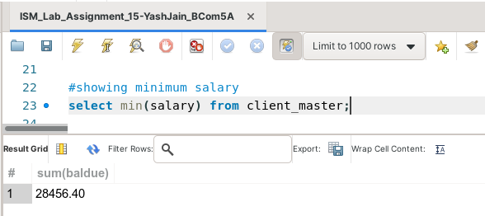

**Task 7: Show the maximum balance of client_master.**

This task can be completed using the **MAX() aggregate function**. The max() function returns the maximum of ‘n’ values of an attribute in a table. The syntax for this is -

Select min([distinct] [<all>] <n>) from <tablename>;

